FORUM: GA3 (Social, Humanitarian & Cultural Issues)
ISSUE: The Question of Penal Labour
STUDENT OFFICER: Alen Korez
POSITION: President

"To reaffirm faith in fundamental human rights, in the dignity and worth of the human person, in the equal rights of men and women and of nations large and small...."

Charter of the United Nations, June 1945, preamble

INTRODUCTION

Penal labour is a generic term for various kinds of unfree labour which prisoners are required to perform, typically manual labour. The work may be light or hard, depending on the context. Forms of sentence involving penal labour have included involuntary servitude, penal servitude and imprisonment with hard labour. The term may refer to several related scenarios: labour as a form of punishment, the prison system used as a means to secure labour, and labour as providing occupation for convicts. These scenarios can be applied to those imprisoned for political, religious, war, or other reasons as well as to criminal convicts.
Large-scale implementations of penal labour include labour camps, prison farms, penal colonies, penal military units, penal transportation, or aboard prison ships.
Imprisonment is the most expensive method of punishment in the western countries as compared to other alternatives. For instance, in Finland, imprisonment costs per prisoner per day are almost three times higher than confinement with electronic monitoring and more than 11 times higher than community service (167€, 60€ and 14€ respectively).
Increasing the use of alternative sanctions may reduce those costs. Nevertheless, a prison sentence is sometimes indispensable, e.g. for dealing with dangerous offenders. Therefore, there is a need in developing methods to reduce prison costs.
The present paper discusses the reduction of imprisonment costs through the improvement of the prison industry. States may use the human capital which the prison accommodates and derive benefits from inmates’ work. An efficient prison industry would provide better work opportunities and wages to inmates. In return, prisoners may partially cover their maintenance costs; improve their work skills; and enjoy from more meaningful activities during their punishment. Those skills may assist the prisoners to find employment after their release, thus, improving the rehabilitation potential. This paper uses the law and economics approach, and applies insight from behavioral law and economics.
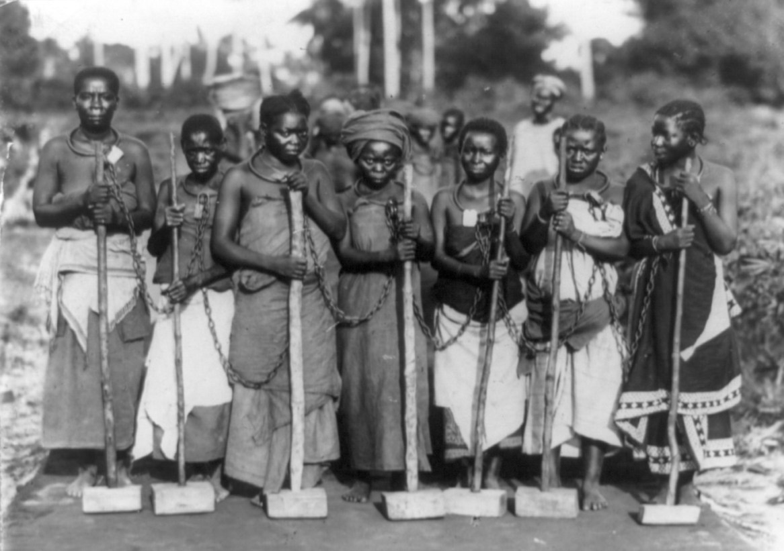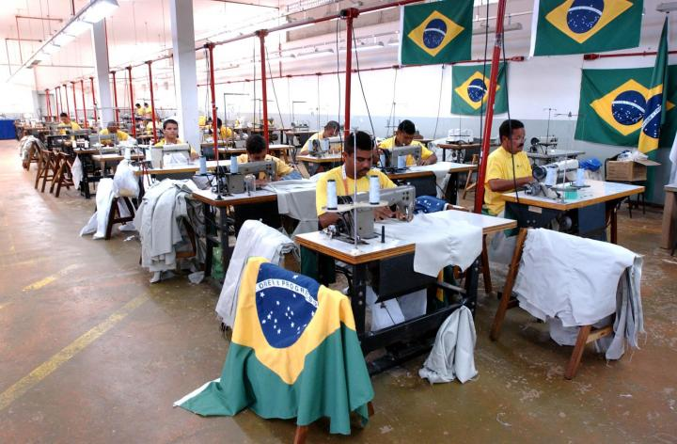

DEFINITIONS OF KEY TERMS

Unfree labour- people are employed against their will with the threat of destitution, detention, violence (including death), compulsion, or other forms of extreme hardship to themselves or members of their families.

Penal/Punitive/Convict/Prison/Hard labour-a generic term for various kinds of unfree labour which prisoners are required to perform, typically manual labour.

Involuntary servitude-a term for a person laboring against that person's will to benefit another.

Penal servitude-imprisonment with hard labour.

Penal colonies-or exile colony is a settlement used to exile prisoners and separate them from the general population by placing them in a remote location, often an island or distant colonial territory.

Rehabilitation-the action of restoring someone to health or normal life through training and therapy after imprisonment, addiction, or illness.

BACKGROUND INFORMATION:

Punitive prison labour:
Punitive labour, also known as convict labour, prison labour, or hard labour, is a form of forced labour used in both past and present as an additional form of punishment beyond imprisonment alone. Punitive labour encompasses two types: productive labour, such as industrial work; and intrinsically pointless tasks used as primitive occupational therapy, punishment and/or physical torment.
Sometimes authorities turn prison labour into an industry, as on a prison farm or in a prison workshop. In such cases, the pursuit of income from their productive labour may even overtake the preoccupation with punishment and/or reeducation as such of the prisoners, who are then at risk of being exploited as slave-like cheap labour (profit may be minor after expenses, e.g. on security).
Non-punitive prison labour:
In a number of penal systems, the inmates have the possibility of a job. This may serve several purposes. One goal is to give an inmate a meaningful way to occupy their prison time and a possibility of earning some money. It may also play an important role in re-socialization as inmates may acquire skills that would help them to find a job after release. It may also have an important penological function: reducing the monotony of prison life for the inmate, keeping inmates busy on productive activities, rather than, for example, potentially violent or antisocial activities, and helping to increase inmate fitness, and thus decrease health problems, rather than letting inmates succumb to a sedentary lifestyle.

CONCLUDING REMARKS:
In many countries, prison is considered as the costliest sanction. It obliges the state to invest resources in accommodating offenders and limiting their freedom. On the other hand, it does not provide direct tangible benefits like fines do. However, a custodial sentence is an important element of the modern criminal justice system. Currently, it is an inevitable sanction which enables incapacitating judgment-proof offenders.
This paper discusses prison labour as a method to reduce imprisonment costs. Prison labour is an accepted practice in the European countries and constitutes part of the activities provided to inmates during their custodial sentence. However, this paper suggests to revise the prison industry’s goals and to restructure the incentive schemes practiced in prisons. To be precise, profit shall be the main aim of the prison industry. This choice of policy might resolve the problem of conflicting goals by providing clarity and at the same time promoting other aims of imprisonment. For instance, introducing incentives for the inmates and private firms may enhance rehabilitation by providing the prisoners with skills and meaningful activity while serving their sentence. Some anecdotal evidence suggests that inmates themselves support prison labour. Although even under the current structure they might be deprived of certain rights in case they refuse to work, employment inside prison is not perceived negatively. In fact, inmates prefer to occupy themselves with work and receive some payment for this rather than stay idle in their cells.

NOTE FROM CHAIR:
I truly hope that this chair report was helpful enough for you to get an introduction into this problem, and that you enjoy your research.

I cannot wait to see you in Ptuj!

USEFUL LINKS:

https://drive.google.com/file/d/1BNh1S3--rvVKAMXoBA7hY_dewgW2BIRz/view -in detail thesis

https://www.researchgate.net/publication/307905871_Reducing_Prison_Costs_through_Prison_Labour_A_Law_and_Economics_Approach

https://en.wikipedia.org/wiki/Penal_labour

http://www.leeswepston.net/prison.htm

