FORUM: GA3 (Social, Humanitarian & Cultural Issues)
ISSUE: The Question of Preventing Sexual Abuse in Conflict Areas
STUDENT OFFICER: Alen Korez
POSITION: President

“sexual violence is a brutal form of physical and psychological warfare rooted in the gender inequality extant not only in zones of conflict, but in our everyday personal lives. the persistence of such forms of violence undermines peace and security and shatters community and family ties. the prevention of sexual violence must remain one of our highest priorities.” - united nations secretary-general António Guterres

INTRODUCTION

The term “conflict-related sexual violence”, as used in the present report, refers to rape, sexual slavery, forced prostitution, forced pregnancy, forced abortion, enforced sterilization, forced marriage, and any other form of sexual violence of comparable gravity perpetrated against women, men, girls or boys that is directly or indirectly linked to a conflict.

DEFINITIONS OF KEY TERMS

Sexual abuse/Molestation is abusive sexual behavior by one person upon another

Wartime sexual violence is rape or other forms of sexual violence committed during war and by war participants

Psychological warfare actions intended to reduce an opponent's morale

Areas of Conflict an area in which a conflict has taken place and evolved into a war.

Sex trafficking is human trafficking for the purpose of sexual exploitation, including sexual slavery

Sexual exploitation generally means to take unfair advantage of a person. Sexual exploitation implies this, but in abusive sexual manners.
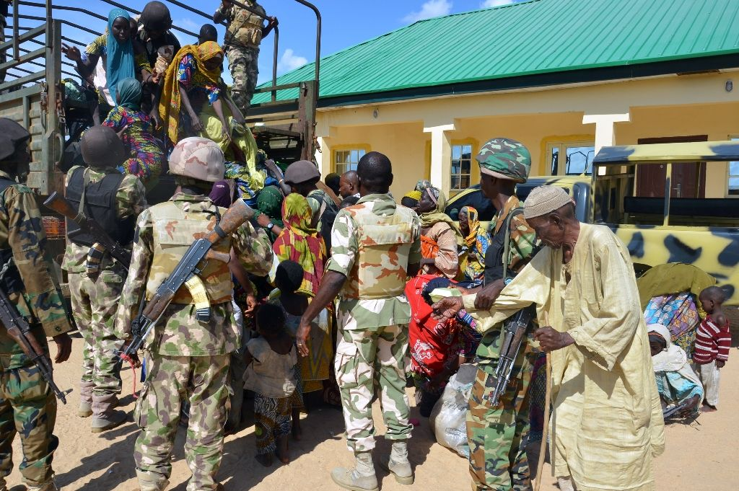

BACKGROUND INFORMATION:

Sexual abuse, also referred to as molestation, is abusive sexual behavior by one person upon another. It is often perpetrated using force or by taking advantage of another. When force is immediate, of short duration, or infrequent, it is called sexual assault. The offender is referred to as a sexual abuser or (often pejoratively) molester. The term also covers any behavior by an adult or older adolescent towards a child to stimulate any of the involved sexually. The use of a child, or other individuals younger than the age of consent, for sexual stimulation is referred to as child sexual abuse or statutory rape.

Wartime sexual violence is rape or other forms of sexual violence committed by combatants during armed conflict, war, or military occupation often as spoils of war; but sometimes, particularly in ethnic conflict, the phenomenon has broader sociological motives. Wartime sexual violence may also include gang rape and rape with objects. It is distinguished from sexual harassment, sexual assaults, and rape committed amongst troops in military service. It also covers the situation where girls and women are forced into prostitution or sexual slavery by an occupying power.
During war and armed conflict, rape is frequently used as a means of psychological warfare in order to humiliate the enemy. Wartime sexual violence may occur in a variety of situations, including institutionalized sexual slavery, wartime sexual violence associated with specific battles or massacres, and individual or isolated acts of sexual violence.
Rape can also be recognized as genocide or ethnic cleansing when committed with the intent to destroy, in whole or in part, a targeted group; however, rape remains widespread in conflict zones. There are other international legal instruments to prosecute perpetrators but this has occurred as late as the 1990s. However, these legal instruments have so far only been used for international conflicts, thus putting the burden of proof in citing the international nature of conflict in order for prosecution to proceed.
Persons may also be the victims of rape used to make a political statement, or to mock a country directly. This make take form in an orchestrated ‘rape fest’ used to break a peace treaty etc.
The term also encompasses trafficking in persons when committed in situations of conflict for the purpose of sexual violence/exploitation.

I URGE MEMBER STATES:
To revise national legal and policy frameworks to ensure that survivors of sexual violence committed by armed and/or terrorist groups are recognized as legitimate victims of conflict and/or terrorism, in order to benefit from reparations and redress;

NOTE FROM CHAIR:
I truly hope that this chair report was helpful enough for you to get an introduction into this problem, and that you enjoy your research.

I cannot wait to see you in Ptuj!

USEFUL LINKS:

https://en.wikipedia.org/wiki/Wartime_sexual_violence (and all connective links)

https://www.un.org/en/events/elimination-of-sexual-violence-in-conflict/pdf/1494280398.pdf (A UN chair report on the subject)

https://en.wikipedia.org/wiki/Sexual_abuse

