Forum: Security Council
Issue: The Question of the United Kingdoms nuclear arsenal post Brexit
Student Officer: Marko Čeh
Position: President chair

Intoducrion:
Brexit is one of the greatest challenges the EU has ever faced. The inability to form a Brexit deal is reason to assume that the economy of the UK, The EU and the global market will take a huge hit, which will lead to civil unrest and protests, but that is not the only security threat we are facing. With Scotland making it very clear that they do not want to leave the EU, they are perhaps triggering a nuclear crisis.

Definition of key terms:
The UK's nuclear arsenal: All British nuclear weapons in Scotland: at the HMNB Clyde in Faslane.
Scotland: Scotland held a referendum to stay in the EU despite Brexit. 62% of votes were to "Remain" in the EU.
Background information: A public vote - or referendum - was held on Thursday 23 June 2016, to decide whether the UK should leave or remain in the EU. Leave won by 52% to 48%. The referendum turnout was very high at 72%, with more than 30 million people voting - 17.4 million people opting for Brexit. Brexit was originally due to happen on 29 March 2019. That was two years after then Prime Minister Theresa May triggered Article 50 - the formal process to leave - and kicked off negotiations. But the Brexit date has been delayed twice. Mrs. May agreed a deal with the EU in November 2018, but MPs rejected it three times.
The new, current Brexit deal involves new custom arrangements. Once they take effect, the UK would be able to sign and implement its own trade agreements with countries around the world.
The revised plan effectively creates a customs and regulatory border between Northern Ireland and Great Britain. This means some goods entering Northern Ireland from Great Britain would have to pay EU import taxes.
Now, with Britain due to leave the EU, remaining part of the UK and holding membership in the EU have begun to look more and more like mutually exclusive options for Scotland, rather than complementary ones. Scotland held a referendum to stay in the EU despite Brexit. 62% of votes were to "Remain" in the EU. This might lead to the UK losing Scotland.

All British nuclear weapons are in Scotland: a total of 120 nuclear warheads on Trident submarines are based at the HMNB Clyde in Faslane, Scotland.
Scotland becoming autonomous would pose a threat to UK's sovereignty and global peace on a larger scale, as it would drastically shake up global power dynamics; not to mention the very unique problem of one county’s nuclear arsenal being located in another country. There would also be massive economic consequences which might lead to civil unrests and protests in the EU.
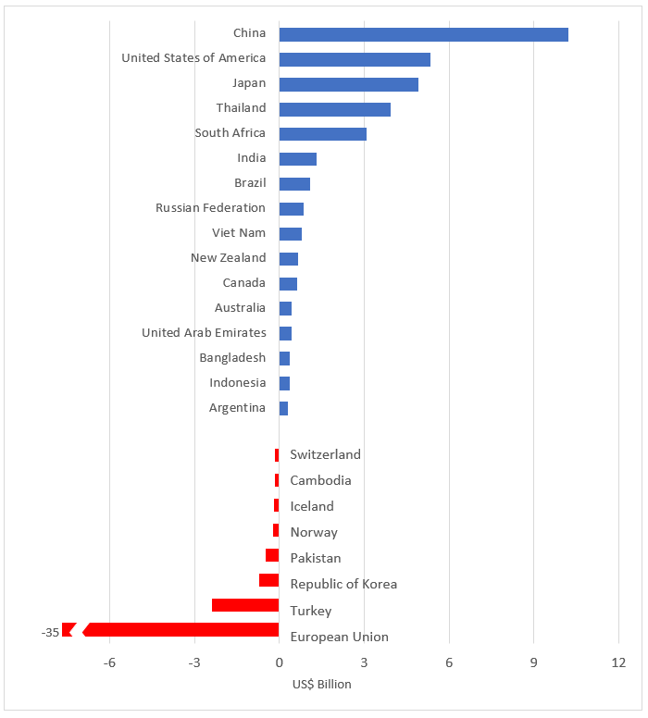

Major players:
Belgium
Belgium would suffer huge losses, with the small Northern European nation losing 2.35 percent of its GDP and 42,390 jobs.
The country, known best for its selection of beers, is expected to see its food and drinks industry worst hit by Brexit.
France
Job losses across France would be around 141,320.
Close trading ties between Britain and France, through the ports of Calais and Dover, could be plunged into chaos if enhanced border checks are implemented as a result of Brexit.
Despite the potential shock employment losses, Paris is adamant that the EU should not renegotiate the Brexit deal.
Germany
Angela Merkel will be forced to explain 291,930 job loses in the event of Brexit.
The importance of Germany’s trade in automobiles, pharmaceuticals, chemical and petroleum products with Britain would result an instant slump in business.
Nuclear weapon states
The potential power shift that would occur plays into the desire of certain states to establish a monopoly on military power as well as getting a larger share of world market trade due to the UK imposing import taxes. That of course needs to be balanced with the duty to maintain world peace.
The United Kingdom
The UK is of course trying its best to work out a good Brexit deal. In this debate the UK needs to balance the economic ramifications of Brexit to ensure Scotland stays a part of it, while somehow reassuring the council that in the case Scotland leaves they would be able to maintain nuclear peace.

Notes from the chair:
The aim of this chair report is to give a complete and brief overview on the topic; this issue is particularly important because of the effect that it has on the rest of the EU and world, including us.
It is important to mention that we are not talking about forming a Brexit deal, but we are rather dealing with its two consequences; namely the UK nuclear arsenal and the civil unrests that would follow the economic shakeup due to Brexit.
I hope that this chair report will help you in your preparation and I wish you a lot good work.
See you in Ptuj.

