FORUM: UNESCO
ISSUE: Protecting UNESCO heritage sites in conflict zones
STUDENT OFFICER: Lovro Letič
POSITION: President chair

INTRODUCTION
A World Heritage Site is a landmark or area which is chosen by the United Nations Educational, Scientific and Cultural Organization (UNESCO) as having cultural, historical, scientific or other form of significance and is legally protected by international treaties. The sites are judged important to the collective interests of humanity. To be selected, a World Heritage Site must be an already-classified landmark, unique in some respect as a geographically and historically identifiable place, having special cultural or physical significance. It may signify a remarkable accomplishment of humanity, and serve as evidence of our intellectual history on the planet. With many (civil) wars being fought around the world especially in Africa and the Middle East a lot of these sites are in danger of being destroyed.

DEFINITION OF KEY TERMS
UNESCO: the United Nations Educational, Scientific and Cultural organization.
World Heritage Site: is a landmark or area which is chosen by UNESCO as having cultural, historical, scientific or other form of significance.
Conflict zone: an area in which a war is being fought.
1954 Hague Convention: The Convention for the Protection of Cultural Property in the Event of Armed Conflict.

BACKGROUND INFORMATION:
The looting and destruction of cultural heritage has been a feature of armed conflict for almost as long we have records of conflict. For thousands of years it was perceived as the right of the victor to take an enemy’s property and destroy what could not be taken. Assyrian reliefs show the sack of temples and the removal of the gods; the colosseum in Rome was built with spoils taken from the sack of Jerusalem; centerpieces of many European national museum collections, including the British Museum and the Louvre, were acquired during campaigns abroad. Although attempts have been made to limit war and set standards for troop conduct, not much has changed. Military theorists from 6th century BC China to 19th century Germany have argued that damaging and destroying the cultural heritage of enemies is bad military practice. However, it was not until after the widespread destruction of cultural property in the Second World War that new international laws were written, focusing exclusively on the protection of cultural property in armed conflict. The laws were written in the 1954 Hague Convention for the Protection of Cultural Property in the Event of Armed Conflict. But many years have passed since the 2nd world war and the lessons it thought us, were forgotten. Few governments have enacted the safeguarding provisions of the Convention to proactively prepare for armed conflict during peacetime. Although some museums have independently prepared refuges for their collections, governments have remained largely uninvolved. Governmental inaction results in lack of military awareness, as armed forces reflect state policy. Few armed forces have established their own specialist personnel or conduct training as the Convention mandates. As the cultural heritage destruction across the Middle East and Africa once again brings the topic to international attention, it is time to revisit those lessons, and to avoid past mistakes.
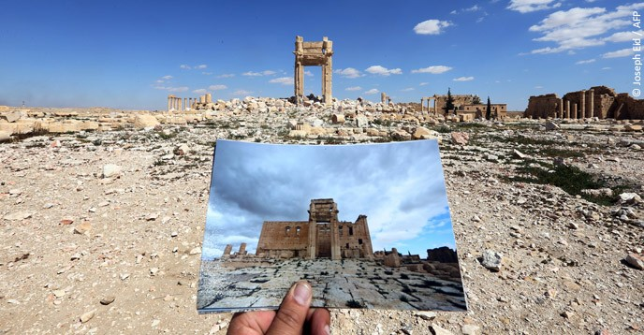
Before and after photographs of the Temple of Bel, one of the most iconic monuments in Palmyra (Syria), destroyed by ISIS in August 2015.
POSSIBLE SOLUTIONS:
Delegates and member states should focus on finding ways to protect World heritage sites and implementing international laws that all countries would have to follow. Delegates should also focus on understanding the importance of these sites to humanity and why protecting World heritage sites is worth the money and effort of all countries.

