FORUM: UNODC (United Nations Office on Drugs and Crime)
ISSUE: The Question of Preventing Domestic and International Terrorism
STUDENT OFFICER: Polonca Škerget, Nika Keres
POSITION: President, CO-chair

»Terrorism is a significant threat to peace and security, prosperity and people. «
- Ban Ki-moon

INTRODUCTION
The use of violence against unarmed civilians has been the gloomy part of human existence. Since the epoch of documented history, influential individuals and groups have been kidnapped and assassinated, and factions have demonstrated as well as perpetrated acts of non-conformity to the law through acts of violence, all in the name of pursuing a higher cause. Globalisation through the dawn of the internet and satellite communication has brought this phenomenon to the homes of people. Terrorist groups have put this technology to their advantage to convey their message to a wider range of audience, engendering empathy and fear. Modern terrorism saw the bombing of the Twin Towers in New York on September 11, 2001, ushering in the threat and use of weapons of mass destruction. The question of preventing domestic and international terrorism seems pretty easily answered at first glance, but it is far more complicated than we think. So how can someone, who is a terrorist, be prevented?

DEFINITIONS OF KEY TERMS

Terrorism: The unlawful use of violence and intimidation, especially against civilians, in the pursuit of political aims.

Domestic: Regarding to a person’s own country.

International: Involving more than one country.

Prevention: The act of stopping something from happening or of stopping someone from doing something.

Law: A rule, usually made by a government, that is used to order the way in which a society behaves.

Juvenile offenders: Criminals aged under 18 years at the time of their crime.

BACKGROUND INFORMATION:

BEGINNINGS: Since the term terrorism can be broadly defined, the roots and practice can be traced at least to the 1st century A.D., where Sicarii Zealots supposedly assassinated collaborators with Roman rule. But the term has firstly occurred, in English, during the French Revolution, when Jacobins, who ruled the revolutionary state employed violence, including the mass executions by guillotine. In 6th century A.D Judas of Galilee formed a small and more extreme offshoot of the Zealots. Their efforts were also directed against Jewish "collaborators," including temple priests and other wealthy elites. In the late 11th century, the Hashshashin (a.k.a. the Assassins) arose, an offshoot of the Isma'ili sect of Shia Muslims. In 1605 there was an attempt to destroy the English Parliament including the Gunpowder plot. The Sons of Liberty was a clandestine group that formed in Boston and New York City in the 1770s. The groups engaged in several acts that could be considered terroristic. The association of the term with governmental groups lasted only until the mid-19th century, later on it was also associated with non-governmental groups. The most prominent ideology linked with terrorism is often anarchism with rising nationalism and antimonarchism. Where at the end of the 19th century an anarchist group committed assassinations of a Russian Tsar and the U.S. President. In the 20th century terrorism is continued to be associated with anarchist, fascist, socialist and nationalist groups, many of which were engaged in the third world anti- colonial struggles.

MODERN DAY TERRORISM:
There are 5 types of terrorism: State-Sponsored terrorism, which consists of terrorist acts on a state or government by a state or government. Dissent terrorism, which are terrorist groups which have rebelled against their government. Terrorists and the Left and Right, which are groups rooted in political ideology. Religious terrorism, which are terrorist groups which are extremely religiously motivated and Criminal Terrorism, which are terrorists’ acts used to aid in crime and criminal profit. Terrorist current methods are: explosive devices, shootings and close quarter attacks, kidnappings, Chemical, Biological and Radiological Devices. We must be aware of the H.O.T. protocol which stands for: HIDDEN-Not in general view and may have deliberately been positioned in a discrete area. OBVIOUS-This is when the item is obviously suspicious, signs of tape, batteries, etc. TYPICAL-Not typical of what is the normal everyday situation, out of the ordinary.
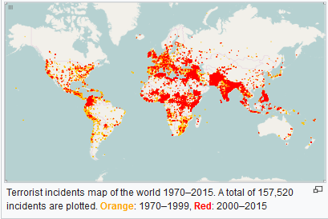
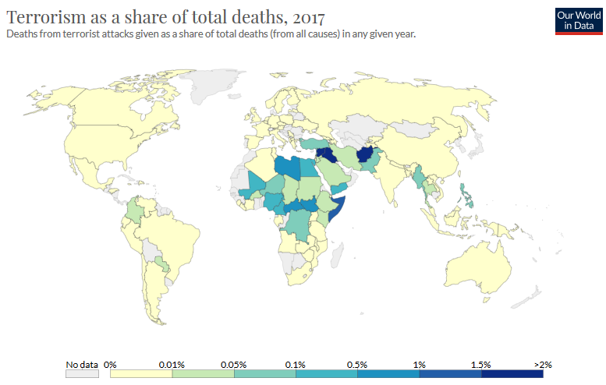

SHORT STATEMENTS TO THINK ABOUT:
Has the Patriot Act helped to make the US safer?
Does data mining help prevent terroristic attacks?
Detect explosives and other weapons.
Help protecting critical infrastructure and cyber networks from attack.
Build information-sharing partnerships.

POSSIBLE SOLUTIONS:
Delegates and member states should focus whether or not and in which ways should we prevent terrorist attacks Terrorism has been a serious threat for ages but since the 9.11. I believe we are more aware of them. Since it can happen in any given point even to us, I believe this matter needs to be discussed, maybe we even innovate something. Maybe there’s a need of increased informing of any suspicious acts. As for the cyber terrorism the agencies, companies etc. should have a proper firewall and maybe even use data coding. On the other hand, different types of places, events should have a technology that detects advanced explosives or weapons, it should rather beep twice a day than to risk again 700 lives. There could also be a scheme made on how different companies would share information and give each other the silent heads up. Compromises in the debate will be needed.

NOTE FROM CHAIR:
Dear delegate,
I hope you got some useful information from this chair report. Since the report is a kind of guidance, I suggest you search for more articles, books, laws etc. regarding your country. I strongly believe you are capable of writing a policy statement and a resolution on this topic. But do not forget, you are representing the believes of the country you have been given. You’re going to do great! I believe we’re going to have an amazing debate on this topic and will make an outstanding resolution, full of compromises and fairness for all.
I am truly looking forward to seeing and meeting you in Ptuj!

USEFUL LINKS:
- https://www.state.gov/reports/country-reports-on-terrorism-2017/
- https://en.wikipedia.org/wiki/Number_of_terrorist_incidents_by_country
- https://ourworldindata.org/terrorism
- How to write a resolution: https://bestdelegate.com/model-un-made-easy-how-to-write-a-resolution/
- Sample policy statement: https://firebird-tours.com/wp-content/dokumente/Sample%20Policy%20Statement.pdf

